**What is the difference between concurrency and parallelism?**

Concurrency – logically operating at once

Parallelism – actually operating at once

**How can parallel computing improve power efficiency of a system?**

clock frequency goes down but capacitance goes up; however, lowered frequency also lowers voltage (P = fCV2)

**Why do we include multiple levels of caches on processors?**

Ultimately everything wants to be on-chip to actually work. You don't want to waste time going down to main memory for small problems when you can shallowly fetch from cache. Ultimately it's the speed/size tradeoff.

**In hw1 why were profiled times wrong if we did not print out final index after pointer chasing?**

If it's "unneeded" then it could perform out of order or not even optimize.

**Explain how simultaneous multithreading (hyperthreading) is related to an out-of-order superscalar processor.**

Out-of-order superscalar is to instructions as hyperthreading is to threads. They break up problems to fully fill the pipeline by executing what computations they can wherever they can.

**Give two examples of micro-architectural advances that can potentially achieve greater than one instruction issued per cycle.**

Pipelining and superscalar

**More than 1 IPC started:** Superscalar and SIMD

**More IPCs finished:** Out-of-order and pipelining

**Reduced clock cycles:** Pipelining and speed up transistors

**How does modularity help the chief architect of a software development team?**

Easier to organize entire project. You can divvy up tasks and narrow down problems more easily, as well as switch out modules in bits and pieces without breaking everything.

**How does modularity help the project leader of a software development team?**

Easier to explain tasks to various task teams, organize the project, assign tasks. Rather than forcing everyone to learn everything you can assign stuff to various focused teams.

**How does modularity help the individual programmer of a software development team?**

You don't have to know how everything works to do your piece. Helps with code reuse.

**Data decomposition:** Splitting up large amounts of data into independent chunks that can be processed in parallel.

**Task decomposition:** Breaking up large instructions into smaller independent chunks that can be processed in parallel.

**A non-pipelined basic processor has a latency of 24 ns for each instruction. If we split the processor into 6 perfectly pipelined stages, what is the new latency per instruction? What was the throughput before and after the pipelining? Make sure to use the correct units. Also please ignore any additional latency induced by the introcution of pipeline stages.**

24ns per instruction; throughput will increase from 1/24ns to 1/4ns

**What is the difference between SIMD and superscalar?**

SIMD = single instruction, multiple data, ex) 1+2+3+4

Superscalar = multiple scalar processing units, ex) 1+2 and 3+4 on two different units

**Almost all programs use which of the structural patterns at their highest level?**

Pipe-and-filter

**Give two concrete reasons why patterns are valuable in software engineering?**

1. You don't need to know the details of a program, just its basic structure

2. Turn programs into modules, which are easier to write and debug

**Please rank the following in order of decreasing latency, and estimate latency in cycles.**

DRAM(200 cycles, 65.1ns) > L3(38 cycles, 13ns) > L2(10 cycles, 3.4ns) > L1(4-8 cycles, 1.3ns)

**Please rank the following in order of decreasing bandwidth, and estimate latency in GB/s.**

DRAM(10.1 GB/s) > L3(26.2 GB/s) > L2(31.1 GB/s) > L1(45.6 GB/s)

**Please rank the following in order of decreasing memory size, and estimate memory size.**

DRAM(12 GB) > L3(8 MB) > L2(128 kB) > L1(32 kB)

**Define the variables a, b, and c to be arrays of double-precision floating-point numbers.**

**double a[N x N], b[N], c[N]**

**where N is a large power of 2. The variable a is interpreted as an nxn matrix in row-major format. B and c are interpreted as vectors of length n. a and b are initialized to arbitrary values while c is initialized to all zeros. Now consider the following naïve matrix vector multiply routine.**

**For (int i=0; i< n; i++) {**

**For (int j=0; j<n; j++) {**

**C[i] = c[i] + a[i*N + j] * b[j];**

**}**

**}**

**What is the total number of flops in the naïve matrix multiply routine in terms of N?**

2N2 (a[i*N + j] doesn't count because it's integers, not floating-point)

Pipe-and-Filter: Everything really

Compiler, Image Retrieval, image classification, Logic Optimizer

Iterator/BSP: SVM Training

MapReduce: Image processing, convolution, feature extraction, edge detection, fluid dynamics, heat maps, speech recognition, calculating sample distance from frontier in SVM, indexing web documents

Structured grid: Image convolution, modeling heat diffusion, modeling fluid dynamics

Scheduling

Latency

Throughput

Resource Management

Data parallelism: element-wise ops, communication reductions, nested parallelism, arbitrary

Matrix-multiply, SVM image classifier

Task parallelism: all other parallel strategies can be described in terms of this

Game engines

BLAS

Level Example #mem refs #flops q

1 y += ax 3n 2n 2/3

2 y += Ax n2 2n2 2

3 C += AB 4n2 2n3 n/2

*everything is task parallelism on some level

*potential for more parallelism within individual agents, tasks, filters, layers, puppets (but not puppeteer)

|  |  |
| --- | --- |
| **Pipe-and-filter** most things pipe/filter@highest level  Strategy: Pipeline  Amt. Parallel: as much as there are filters  Examples: Compiler, Image Retrieval, Logic Optimizer  **[L]** |  |
| **Iterator [D]**  Strategy: Data, Task, Pipeline…depends on what's inside  Amt. Parallel: All parallelism inside blocks within iterator loop  Examples: Support Vector Machine Training |  |
| **Map-Reduce [H]**   * computations mapped onto independent data * results then summarized (reduce)   Strategy: Data  Amt. Parallel: A LOT; potential as much as # datasets mapped onto  Examples: SVM, Speech Rec, Img proc, convolution, feature extraction, edge detection, fluid dynamics, heat maps, index web docs |  |
| **Agent/Repository [M]**   * Blackboard structural pattern * Blackboard=repo shared by all agents (circuit database) * Agents=act on blackboard (optimization) * Manager=control blackboard access/collect results (scheduler)   Strategy: Task; Data if repo can be partitioned into datasets  Amt. Parallel: As much as #agents; data in repo; repo is bottleneck  Examples: Compiler Optimization |  |
| **Process Control [L]**   * Processor=underlying phenomena to be controlled/computed * Actuator=tasks affecting process * Sensor=tasks analyzing state of process * Controller=tasks controlling which actuators should be affected   Strategy: Task, Discrete Event  Amt. Parallel: For each significant task  Examples: Thermostat |  |
| **Model-View-Controller [M]**   * Model=data/intelligence (business logic) of system * Controller=capture input, translate to action on model * View=renders current state of model for user   Strategy: Task  Amt. Parallel: One task for each of model, view, controller  Examples: Popup charts thing |  |
| **Layered Systems [L]**   * Individual layers big; interface between layers narrow * Nonadjacent layers can't directly communicate   Strategy: Task  Amt. Parallel: One task for each layer  Examples: OSI Network Protocol |  |
| **Event-Based Systems [L]**   * Agents interact via events/signals in medium * Event manager manages events * Interaction among agents dynamic; no fixed connection   Strategy: Task  Amt. Parallel: 1 task for each agent + event manager  Examples: Internet |  |
| **Puppeteer [H]**   * Guide interaction between simulation code * No central repo; data transfer between simulators   Strategy: Task  Amt. Parallel: 1 for each puppet + puppeteer  Examples: Blood flow through vessels computations |  |
| **Static Task Graph [L]**   * Tasks receive inputs; produce outputs * All data sharing through explicit messaging * Task config statically defined; cannot be changed at runtime   Strategy: Task  Amt. Parallel: 1 for each task  Examples: One game architecture |  |

**Layers of Parallelism**

Top level: iterator little parallelism

Mid level: pipe-and-filter some parallelism

Low level: mapreduce lots of parallelism

*Agent/repo, static-task, event-based

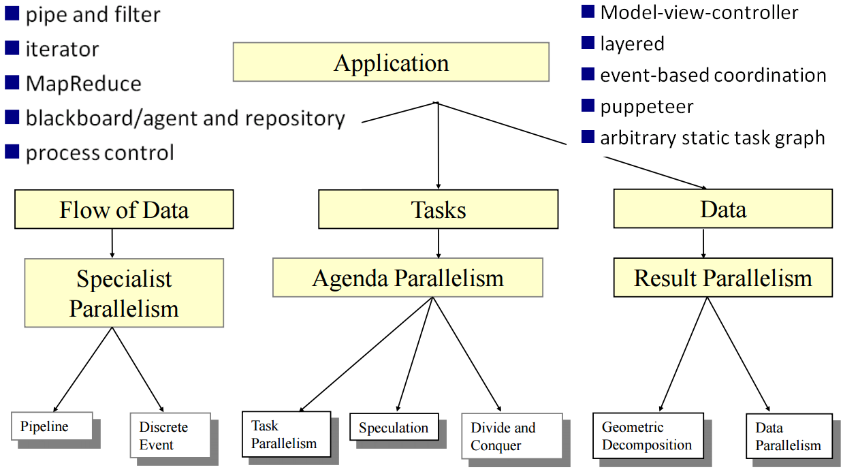

**Logic Optimization:** Pipe-and-filter

**Representing 1 circuit:** Agent-and-repository

**Optimizing Circuit Area:** Process Control

**Remap Circuit Gates:** Dynamic Programming

**Static Time Analysis:** Graph Algorithm/Dynamic Programming